Faxitron digital X-ray user manual

As you may have noticed, we now have a digital X-ray machine in the Imaging Core. This machine is easy to use and provides features to streamline some processes, including:

* Automatic scan parameter selection
* On-image text annotation (no more need for little metal letters and numbers)
* Automatic edge enhancement to better view bone geometry
* A true database storage system for better study organization

So, here’s how to use it:

**Starting the Machine**:

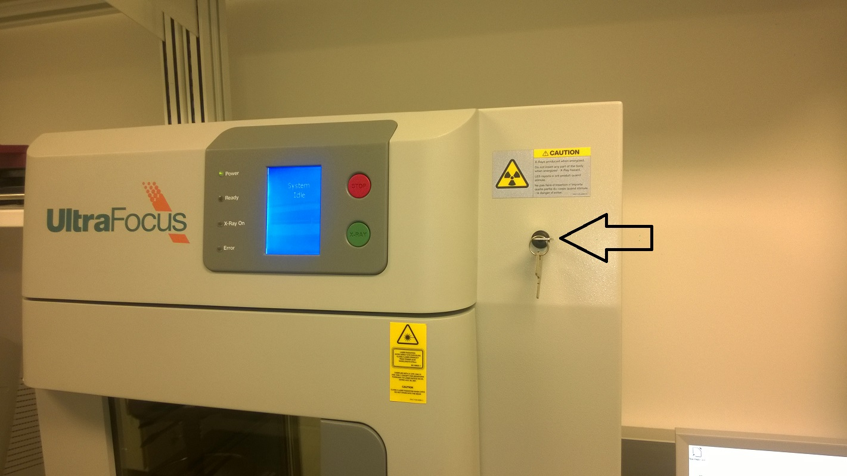

If you are the first user of the day, you’ll likely have to turn the machine on. Do so by turning the key to the right. Good work, you’re done!

**Starting the Software**:

If you’re the first user of the day, when you launch the software (the X in the middle of the desktop), it will prompt you to do a calibration. Follow the prompts on the screen to allow it to calibrate. Note: when prompted, make sure the plastic tray is out of the machine.

**Starting a Scan**:

Doing the actual scans with the new cabinet is much easier than when using a film-based scanner; however, you must first set up your experiment in the database. NOTE: DO NOT MAKE A NEW PATIENT/SUBJECT EVERY TIME YOU SCAN. You will be yelled at by the lab manager and charged money for extra work required for organizing billing every month. Only make a new Patient/Subject entry when you are starting a new study – treat this the same way the sample number is treated when CT scanning.

**If starting a new study**:

Assuming the software is already launched and has been calibrated, click on Start Procedure in the upper left hand corner. Next, click on Sample Data, also in the upper left.

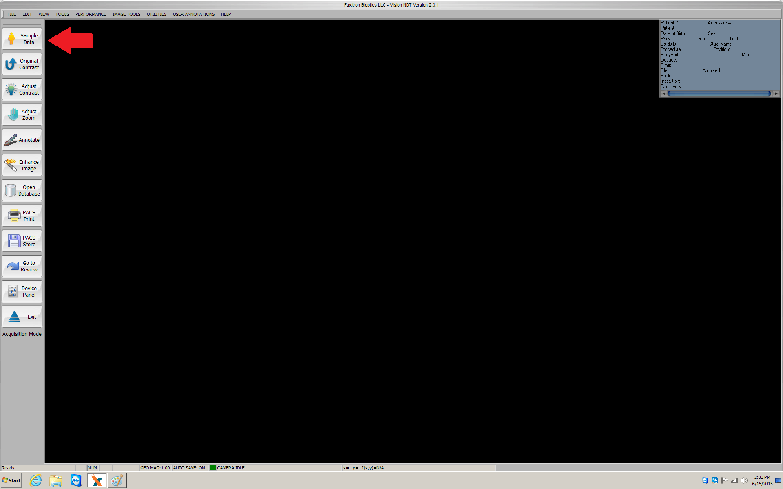

Next, click on Enter Manually.

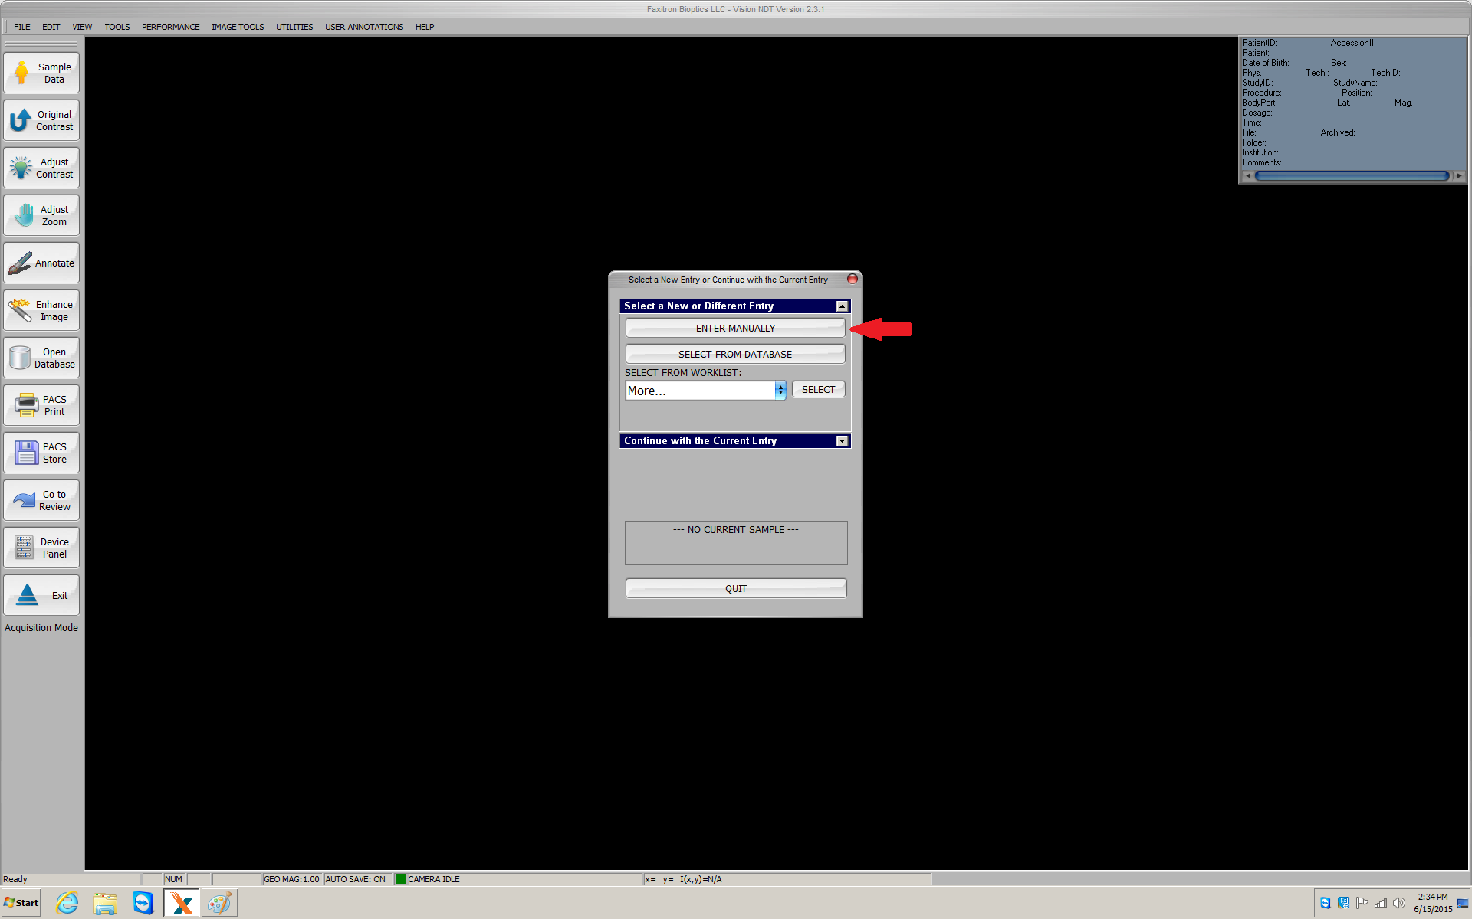

Fill out the fields with information as noted below – they won’t all make total sense, as the software is configured as though it were being used for human clinical X-rays. Once the fields are filled in, press start.

.

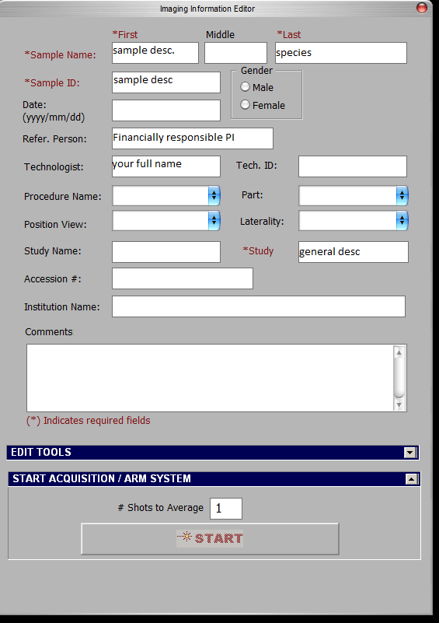

Now, to take X-rays, simply hit the green button on the machine. Every scan will be saved, and you will be charged for each and every one. Be judicious! Once it has scanned your object and reconstructed the image on your screen, right click on the image, select annotate, and select text. Then, type something in to identify the object. This text annotation will be automatically saved.

**If continuing a study**:

If continuing a study, rather than pressing Enter Manually, press Select From Database when presented with this dialog:

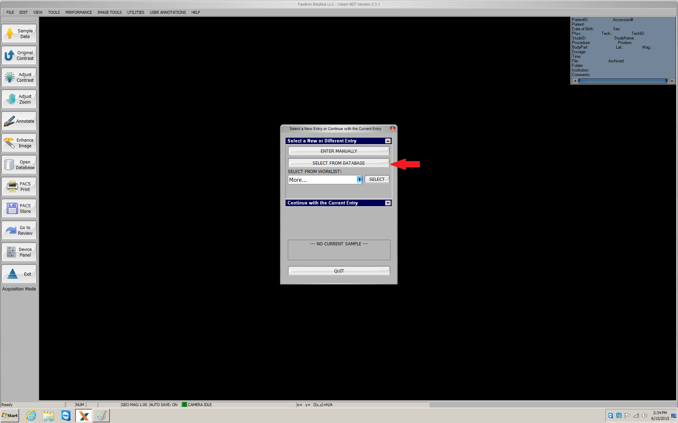

Remember to fully fill in the fields as if you were starting a new study! Some information is not automatically carried over. Once filled in, press Start.

Now, to take X-rays, push the green button on the machine. Once it has scanned your object and reconstructed the image on your screen, right click on the image, select annotate, and select text. Then, type something in to identify the object. This text annotation will be automatically saved.

**Putting Stuff on the Tray**:

The tray for the X-ray cabinet is marked off with areas that will be within the scan for different zoom levels. For example, if a 3x zoom is desired, make sure the entirety of your sample sits within the rectangle on the plastic tray marked as 3, and that you put the tray in the level in the scanner marked as 3. That’s it!

**Loading Previous Scans**:

If you need to load previous scans to view them or export images or whatever, when starting the software, click on Open Database

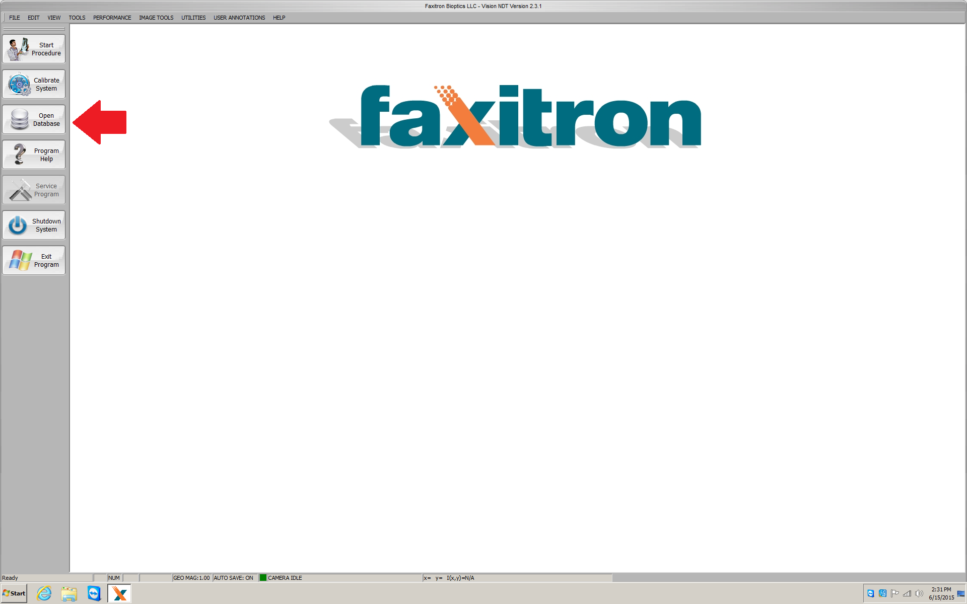

and then double click on the appropriate lines when they appear as marked by green arrows.

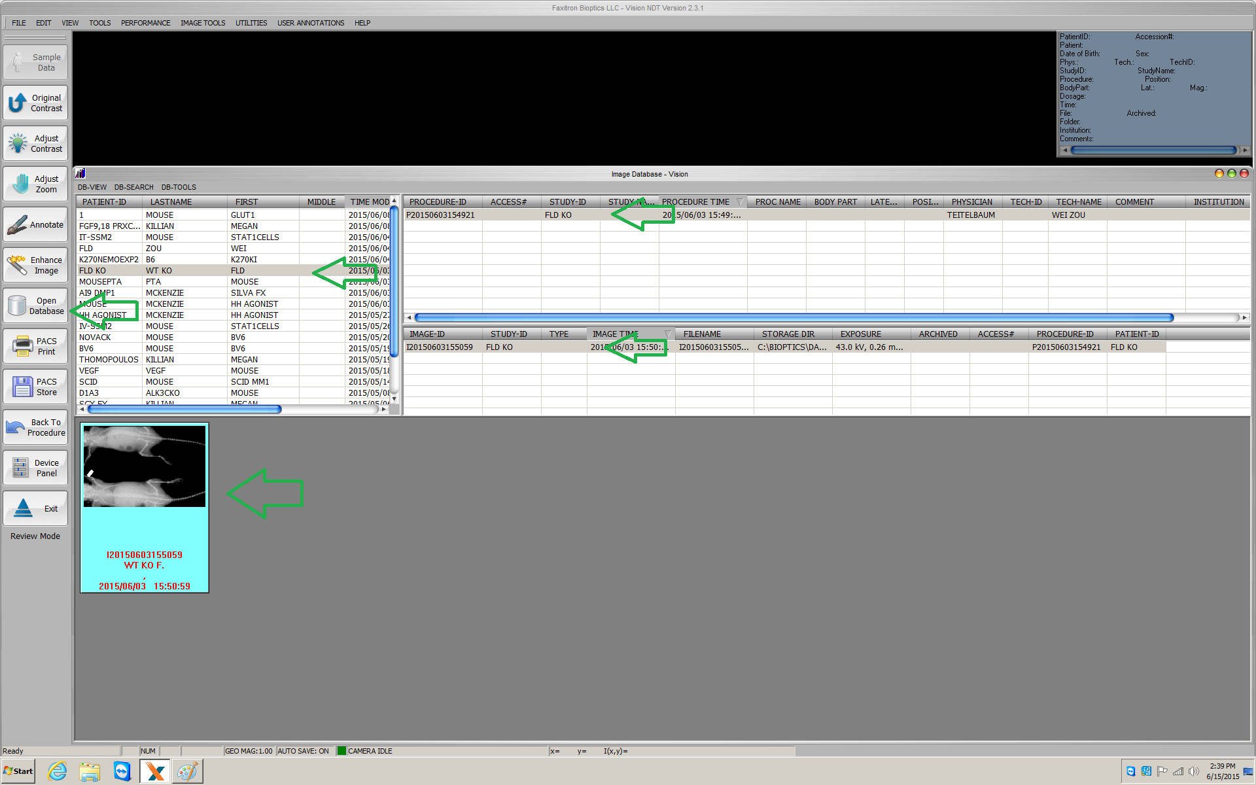

**To Save An Image as a TIF or other Image File**:

First, either open the scan as described previously, or leave the scan up after it has been reconstructed. Then, go to File -> Save As and save the image as you would in any other program ever. The trick is that any annotations will be saved in the file as well, so be sure to delete ones you don’t want. There is also one VERY ANNOYING bug in the software – if you click on any other file when saving, it will overwrite that file. So, DO NOT click on another picture to populate the filename field and then try to change one character (a common usage attempt). It will overwrite the file you clicked on. Don’t do that. Just type the full file name in the field every time until they fix this (haha they won’t fix it).